|  |  |
| --- | --- |
| EGC_Black | **Mathematics Methods**  **Investigation 1**  **Heron’s Rule** |

There are two parts to this investigation. Part A is a take-home assignment, of which you have five days to complete. I will check your work in class on **Tuesday 28th March.**

The solutions to Part A will be posted on the pin up board outside the Mathematics Office on the morning of **Wednesday 1st March.**

Part B is an in-class investigation. You will be allowed to use your Part A while completing the validation on **Friday 3rd March**.

**Take Home Section Due:**

**NAME** \_\_\_\_\_\_\_\_\_\_\_\_\_\_\_\_\_\_\_\_\_\_\_\_\_\_\_\_\_\_\_\_\_\_\_\_\_\_\_\_\_\_\_\_\_\_\_\_\_

The rules you have used to calculate the area of a triangle are A = ½bh, where b is the length of the base and h is the perpendicular height, and A = $\frac{1}{2}abSinC$, where a and b are lengths of 2 sides and C is the angle between them.

[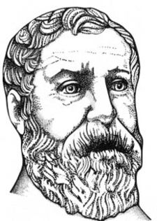](http://en.wikipedia.org/wiki/File:Heron.jpeg)

However outside the school classroom people rarely have the base and the perpendicular height or an angle. They are more likely to be given the lengths of the 3 sides of the triangle. In 60 AD the mathematician Heron of Alexandria published a book with a rule for calculating the area of a triangle and ever since then it has been known as Heron’s rule. It seems however that Archimedes knew the rule over 300 years before Heron!!!

|  |  |
| --- | --- |
|  | ***s is called the semi-perimeter.*** |
| Area = |

Question 1:

1. Use Heron’s formula to calculate the area of the scalene triangle shown below.

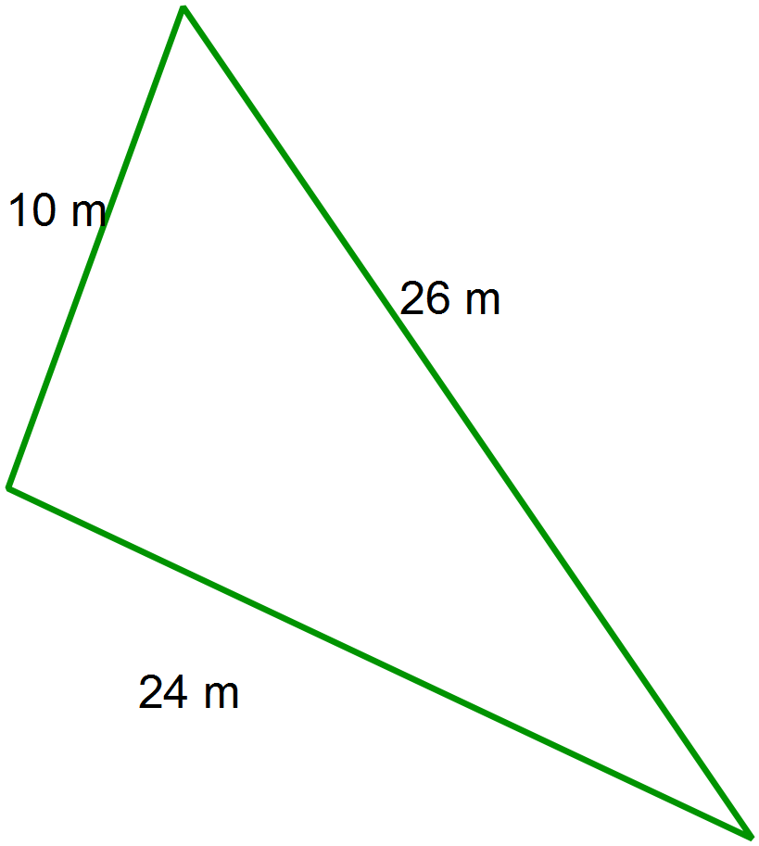

1. Use Pythagoras’ Theorem to prove that this triangle is right angled.

1. Use this result to show the area calculated from Heron’s Rule is correct.

Question 2:



1. Use Heron’s rule to determine the area

of this isosceles triangle, with a perimeter of 36 cm.

1. Find the perpendicular height of the triangle in part (a).

Show all working.

1. Use another method to determine the area of this triangle to confirm your solution to

part a.

Question 3:

1. Consider the following lengths of the sides of triangles each with a perimeter of 30cm

(semi-perimeter of 15).

***Impossible?***

Find the area of each using Heron’s rule.

***Isosceles triangles?***

(8,10,12) (7,9,14)

***Equilateral?***

(6,11,13) (10,10,10)

***Scalene?***

(9,9,12) (8,8,14)

***Maximum Area?***

(3,10,17) (7,7,16)

***Heron’s rule on NumSolve?***

(4,12,14) (5,11,14)

Try some other triangles of your own with a fixed perimeter of 30 cm.

Show your solutions below.

1. Discuss what you found.

* Which triangles are impossible? Why? What happens to Heron’s rule with these impossible triangles? What relationship must exist between a, b and c for the numbers to form a triangle?
* What type of triangles create the largest area?
* Can you find a rule for the area of the largest triangle in terms of the semi-perimeter (s)?

Justify your answer using algebraic steps.

* What are the sides of a triangle with the smallest perimeter possible with a maximum area of 1000 m2? Explain how you found this. What procedure did you use?